**Experiment Number: 8 Date: 24.02.2026**



**Implementation of Packages in Java**

**Aim:**

**Write a Java program to implement built-in, user-defined packages and accessing all classes in a package.**

**PRE LAB EXERCISE**

**QUESTIONS**

1. **What is java.util package? java.util is a core Java package that provides utility classes and the Java Collection Framework (JCF) for storing and managing data.**

**Collection Framework includes:**

* + **Interfaces: List, Set, Queue, Map**
  + **Classes: ArrayList, LinkedList, HashSet, TreeSet, HashMap, TreeMap, PriorityQueue, Vector, Stack**

**It is mainly used to store and manipulate groups of objects.**

1. **Types of packages in Java:** 
   1. **Built-in packages – Predefined (e.g., java.lang, java.util, java.io).**
   2. **User-defined packages – Created by the programmer using the package keyword.**

**IN LAB EXERCISE**

**Objective**

**To understand and implement the concepts of built-in, user-defined packages and accessing all classes in a package in Java.**

**Built-in Packages comprise a large number of classes that are part of the Java API. Some of the commonly used built-in packages are:**

* + **java.lang: Contains language support classes(e.g, classes that define primitive data types, math operations). This package is automatically imported.**
  + **java.io: Contains classes for supporting input/output operations.**
  + **java.util: Contains utility classes that implement data structures such as Linked Lists and Dictionaries, as well as support for date and time operations.**
  + **java.applet: Contains classes for creating Applets.**
  + **java.awt: Contains classes for implementing the components for graphical user interfaces (like buttons, menus, etc). Source Code**

**import java.util.Random; // built-in package public class Sample{ public static void main(String[] args) { // using Random class**

**Random rand = new Random(); // generates a number between 0–99 int number = rand.nextInt(100);**

**System.out.println("Random number: " + number);**

**}**

**}**

**Output**

**Random number: 49**

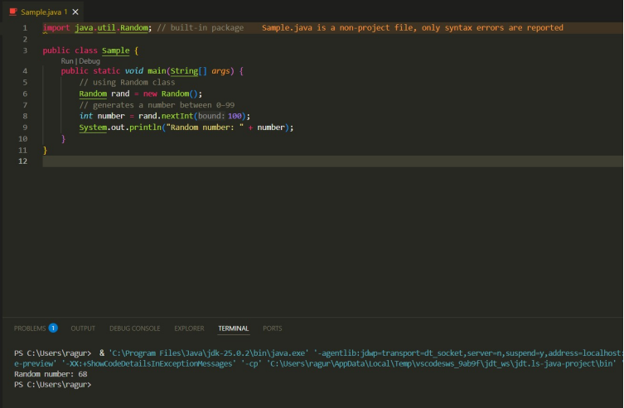

**User-defined Packages are the packages that are defined by the user. Source code package com.myapp; public class Helper { public static void show() {**

**System.out.println("Hello from Helper!");**

**}**

**}**

**==To use this in another class== import com.myapp.Helper; public class Test {**

**public static void main(String[] args) {**

**Helper.show();**

**}**

**}**

**Output:**

**Hello from Helper!**

**//Importing all classes from a package. Source code**

**import java.util.Vector; public class Coders { public Coders() {**

**// java.util.Vector is imported, We are able to access it directly in our code. Vector v = new Vector(); java.util.ArrayList l = new java.util.ArrayList(); l.add(3);**

**l.add(5);**

**l.add(7);**

**System.out.println(l);**

**}**

**public static void main(String[] args) { new Coders();**

**}**

**}**

**Output**

**[3,5,7]**

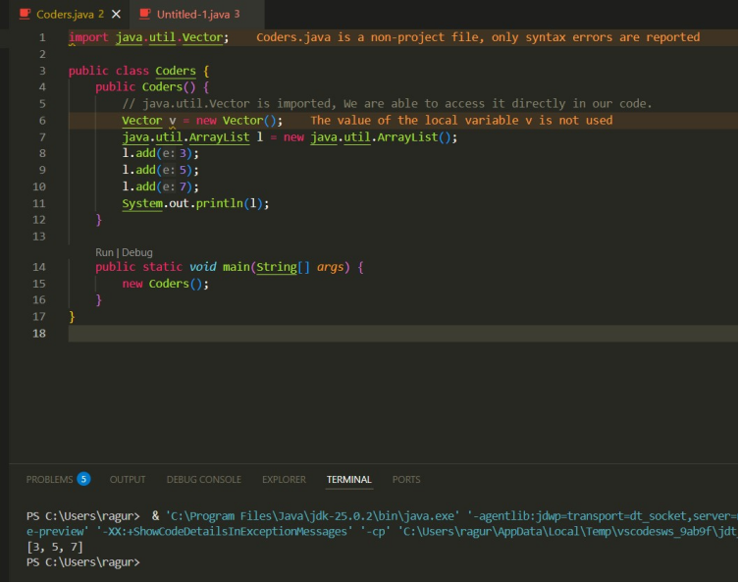

**POST LAB EXERCISE**

1. **Same class name from different packages?**

**It causes a compile-time ambiguity error.**

**Use fully qualified names (e.g., package1.Sample) to avoid confusion.**

1. **Purpose of packages in Java:** 
   * **Organize classes**
   * **Avoid naming conflicts**
   * **Improve readability and maintenance**
   * **Provide access control •Support code reusability**
2. **Package for GUI window?**

**Correct answer: C. java.awt**

**Used to create GUI components like windows and buttons.**

**ASSESSMENT**

|  |  |  |
| --- | --- | --- |
| **Description** | **Max Marks** | **Marks Awarded** |
| **Pre Lab Exercise** | **5** |  |
| **In Lab Exercise** | **10** |  |
| **Post Lab Exercise** | **5** |  |
| **Viva** | **10** |  |
| **Total** | **30** |  |
| **Faculty Signature** |  |  |

**Experiment Number: 9 Date: 24.02.2026**



**Implementation of a Java Program to import packages using different methods**

**Aim:**

**Write a Java program to import packages using different methods for different use cases.**

**PRE LAB EXERCISE**

**QUESTIONS**

1. **Importing in Java:** 
   * **Single class: import packageName.ClassName; Example: import java.util.Scanner;**
   * **All classes: import packageName.*; Example: import java.util.*;**
2. **Default imported package: java.lang**

**It includes classes like String, System, Math, Integer, and Object. No need to import it explicitly.**

**IN LAB EXERCISE**

**Objective**

**To understand and implement the Java packages using different methods and import them.**

**Problem**

**Define a package named ‘useFul’ with a class names ‘UseMe’ having following methods:**

1. **area()- To calculate the area of given shape.**
2. **salary()- To calculate the salary given basic Salary,da,hRA.**
3. **percentage()-To calculate the percentage given total marks and marks obtained.**
4. **Develop a program named ‘Package Use’ to import the above package ‘useFul’ and use the method area().**
5. **Develop a program named ‘manager’**

**Source Code**

**//Package Creation: package useFull; import java.util.*; public class UseMe**

**{**

**Scanner obj=new Scanner(System.in); public static void area()**

**{**

**class method{ void aos(int a)**

**{**

**System.out.print("\nArea of square with length "+a+" is "+(a*a));**

**}**

**void aor(int a,int b)**

**{**

**System.out.print("\nArea of reactangle with dimensions "+a+" & "+b+" is "+(a*b));**

**}**

**void aoc(int r)**

**{**

**double a=3.14*r*r;**

**}**

**System.out.print("\nArea of circle with radius "+r+" is "+a);**

**}**

**void aot(int a,int b)**

**{**

**float ar=(a*b)/2;**

**System.out.print("\nArea of triangle with dimensions "+a+" &"+b+" is "+ar);**

**} }**

**Scanner obj=new Scanner(System.in); method m=new method();**

**System.out.print("\n1.Square\n2.Rectangle\n3.Circle\n4.Triangle\nSelect the shape\n"); int ch=obj.nextInt();**

**UseMe u=new UseMe(); switch(ch)**

**{**

**case 1:System.out.print("\nEnter the length of side of square : "); int s=obj.nextInt();m.aos(s); break; case 2:System.out.print("\nEnter the dimensions of rectangle : "); int l=obj.nextInt(); int b=obj.nextInt(); m.aor(l,b); break; case 3:System.out.print("\nEnter the radius of circle : "); int r=obj.nextInt(); m.aoc(r); break; case 4:System.out.print("\nEnter the dimensions of triangle : "); int ba=obj.nextInt(); int w=obj.nextInt(); m.aot(ba,w); break; } }**

**public void salary()**

**{**

**int ba,da,hra;**

**System.out.print("\nEnter the basic salary : "); ba=obj.nextInt();**

**System.out.print("\nEnter the dearness allowance :"); da=obj.nextInt();**

**System.out.print("\nEnter the house rent allowance : "); hra=obj.nextInt();**

**System.out.print("\nThe total Gross salary of employee is : "+(ba+da+hra));**

**}**

**public void percentage()**

**{**

**int n,sum=0; float p;**

**System.out.print("\nEnter the total number of subjects : "); n=obj.nextInt(); int m[]=new int[n];**

**System.out.print("\nEnter the marks of "+n+" subjects : "); for(int i=0;i<n;i++)**

**{**

**m[n]=obj.nextInt();**

**}**

**for(int i=0;i<n;i++)**

**{**

**sum=sum+m[i];**

**}**

**p=sum/n;**

**{**

**System.out.print("\nPercentahe of student : "+p);**

**}**

**}**

**}**

**//Package Implementation-1: import useFull.UseMe; class packageUse**

**{**

**public static void main(String args[])**

**{**

**UseMe o=new UseMe();o.area();**

**}**

**}**

**Output javac packageUse.java java packageUse**

1. **Square**
2. **Rectangle**
3. **Circle**
4. **Triangle**

**Select the shape**

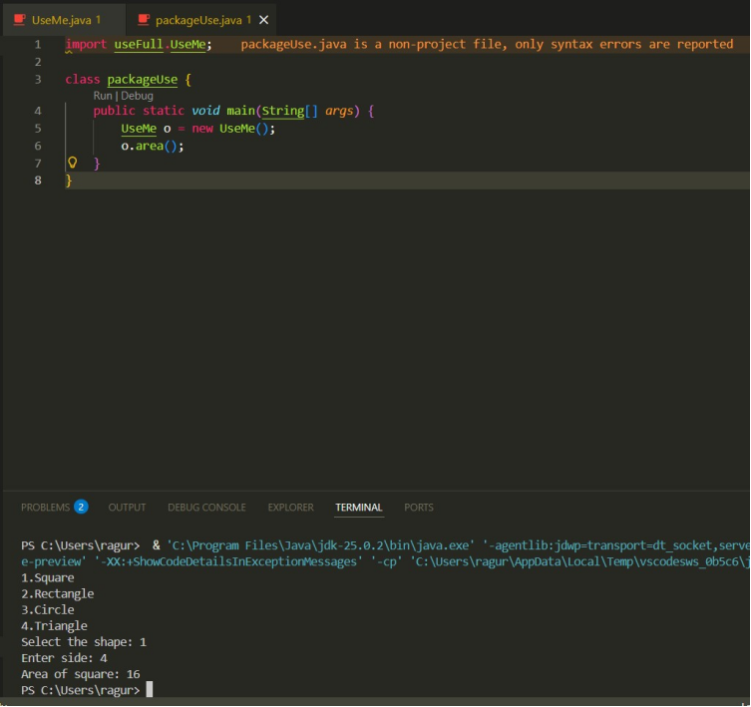

**2 )Enter the dimensions of the rectangle: 10 15 Area of the rectangle with dimensions 10&15 is 150 //Package Implementation-2:**

**import useFull.UseMe; class manager**

**{**

**public static void main(String args[])**

**{**

**UseMe obj=new UseMe();obj.salary();**

**}**

**}**

**Output javac manager.java java manager**

**Enter the basic salary: 100000**

**Enter the dearness allowance: 5000**

**Enter the house rent allowance: 2000**

**The total Gross salary employee is: 107000**

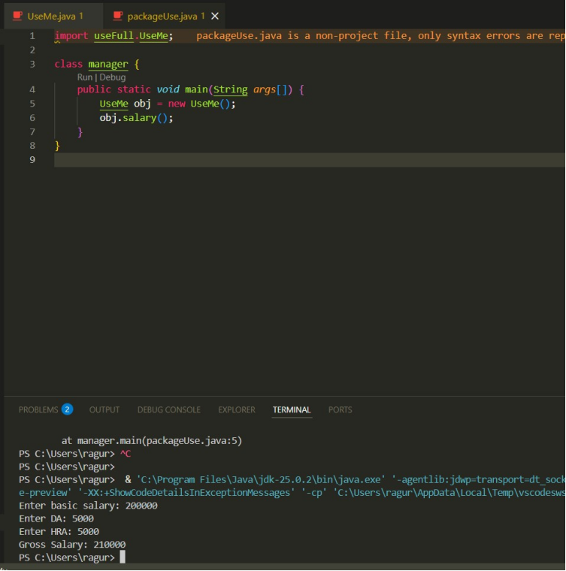

**POST LAB EXERCISE**

1. **Difference between java.lang and java.util:** 
   * **java.lang → Automatically imported; provides core classes like String, System, Math, Integer.**
   * **java.util → Must be imported; provides utility classes like Scanner, Random, ArrayList, HashMap, Date.**



1. **Subpackages of java.util:** 
   * **java.util.concurrent**
   * **java.util.function**
   * **java.util.logging**
   * **java.util.stream**
   * **java.util.regex**
   * **java.util.zip**
   * **java.util.jar**

**They support concurrency, streams, logging, regex, compression, etc.**

**ASSESSMENT**

|  |  |  |
| --- | --- | --- |
| **Description** | **Max Marks** | **Marks Awarded** |
| **Pre Lab Exercise** | **5** |  |
| **In Lab Exercise** | **10** |  |
| **Post Lab Exercise** | **5** |  |
| **Viva** | **10** |  |
| **Total** | **30** |  |
| **Faculty Signature** |  |  |

**Experiment Number : 10 Date:**

**Implementation of Access Modifiers in Java**

**Aim:**

**Write a Java program to implement different access modifiers.**

**PRE LAB EXERCISE**

**QUESTIONS**

1. What are the 4 access modifiers available in Java?

Java provides **four access levels**:

* **private**
  + Accessible **only within the same class**
  + Used for data hiding (encapsulation)
* **default (no modifier)**
  + Accessible **within the same package only**
  + If you don’t write any modifier, this is applied automatically
* **protected**
  + Accessible **within the same package**
  + Also accessible in **subclasses (child classes)** in other packages
* **public**
  + Accessible **from anywhere** (inside and outside the package)

1. Which access modifiers can be used in Java to control access to class members?

For **class members (variables, methods, constructors)**, Java allows **all four access modifiers**:

| **Modifier** | **Can be used for class members?** |
| --- | --- |
| private | Yes |
| default | Yes |
| protected | Yes |
| public | Yes |

**IN LAB EXERCISE**

**Objective**

To demonstrate different access modifiers such as Default, Private, Protected and Public using Java programs.

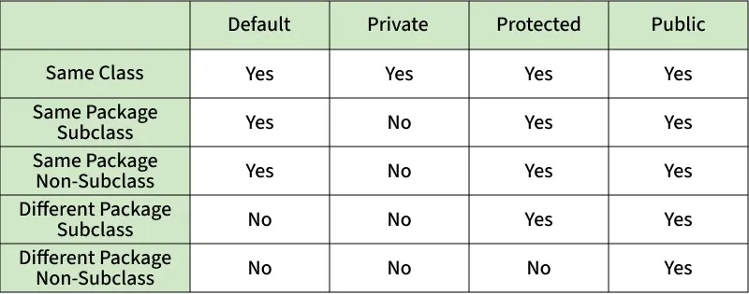

Fig: Comparison table of Access Modifiers in Java

**Source Code**

**// Default Access modifier**

class Car {

String model; // default access

}

public class Main {

public static void main(String[] args){

Car c = new Car();

c.model = "Tesla"; // accessible within the same package

System.out.println(c.model);

}

}

**Output:**

Tesla

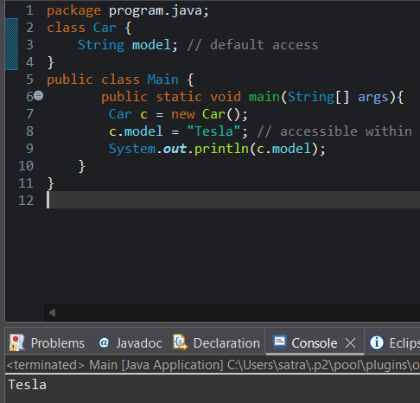

**//Private Access Modifier**

class Person {

// private variable

private String name;

public void setName(String name) {

this.name = name; // accessible within class

}

public String getName() {

return name;

}

}

public class Geeks {

public static void main(String[] args)

{

Person p = new Person();

p.setName("Alice");

// System.out.println(p.name);

// Error: 'name'

// has private access

System.out.println(p.getName());

}

}

**Output**

Alice

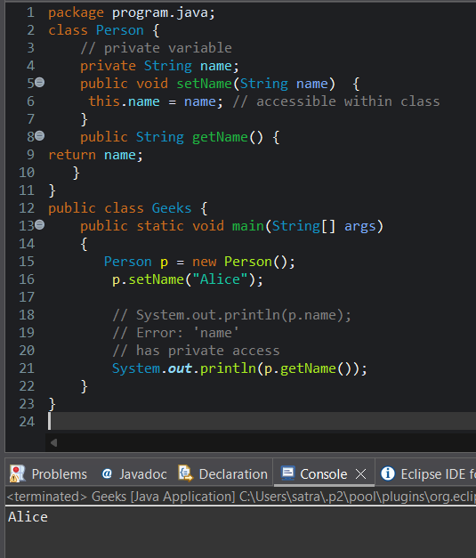

**//Protected Access Modifier**

class Vehicle {

protected int speed; // protected member

}

class Bike extends Vehicle {

void setSpeed(int s)

{

speed = s; // accessible in subclass

}

int getSpeed()

{

return speed; // accessible in subclass

}

}

public class Main {

public static void main(String[] args){

Bike b = new Bike();

b.setSpeed(100);

System.out.println("Access via subclass method: "+ b.getSpeed());

Vehicle v = new Vehicle();

System.out.println(v.speed);

}

}

**Output**Access via subclass method: 100

0

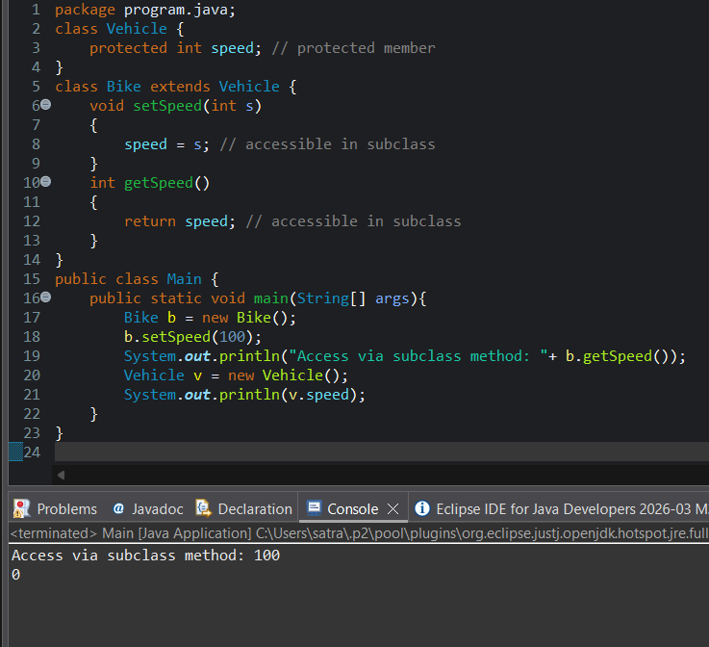

**//Public Access Modifier**

class MathUtils {

public static int add(int a, int b) {

return a + b;

}

}

public class Main {

public static void main(String[] args) {

System.out.println(MathUtils.add(5, 10)); // accessible anywhere

}

}

**Output**

15

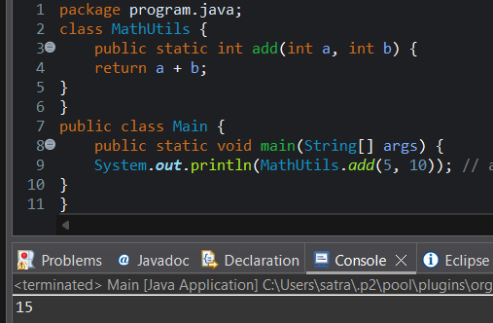

**POST LAB EXERCISE**

* 1. Write a Java program to implement Default access modifier which has a default class within the same package and a default class from a different package.

Package 1: mypack1

**File: DefaultClass.java**

package mypack1;

// default access class (no public keyword)

class DefaultClass {

void show() { // default access method

System.out.println("Hello from DefaultClass (same package)");

}

}

**File: SamePackageTest.java**

package mypack1;

public class SamePackageTest {

public static void main(String[] args) {

DefaultClass obj = new DefaultClass();

obj.show();

}

}

**Package 2: mypack2**

**File: DifferentPackageTest.java**

package mypack2;

import mypack1.DefaultClass;

public class DifferentPackageTest {

public static void main(String[] args) {

DefaultClass obj = new DefaultClass();

obj.show();

}

}

A **default access class and its members are not accessible outside the package.**

Output (only same package program runs)

Hello from DefaultClass (same package)

* 1. Which access modifier provides the highest level of access?

**public provides the highest level of access.**

**Reason:**

* **public members can be accessed:**
  + **within the same class**
  + **within the same package**
  + **in subclasses**
  + **from other packages**

**ASSESSMENT**

|  |  |  |
| --- | --- | --- |
| **Description** | **Max Marks** | **Marks Awarded** |
| Pre Lab Exercise | **5** |  |
| In Lab Exercise | **10** |  |
| Post Lab Exercise | **5** |  |
| Viva | **10** |  |
| **Total** | **30** |  |
| **Faculty Signature** | |  |

**Experiment Number :11 Date:**

**Implementation of multiple inheritance in Java using Interface**

**Aim:**

**Write a Java program to implement multiple inheritance using Interface.**

**PRE LAB EXERCISE**

**QUESTIONS**

1. Why Java does not support multiple inheritance using classes like that of C?

Java does not support multiple inheritance with classes to **avoid ambiguity and complexity**, especially the Diamond Problem, where the compiler cannot decide which parent class method to inherit.

1. What is the primary purpose of an interface in Java?
2. To store data using instance variables
3. To define a contract of methods a class must implement
4. To allow creation of objects
5. To improve runtime performance

**Correct Answer:**  
**B. To define a contract of methods a class must implement**

The primary purpose of an interface in Java is to **define a contract of methods** that implementing classes must follow, ensuring consistency and abstraction.

**IN LAB EXERCISE**

**Objective**

To demonstrate how an interface in Java defines constants and abstract methods, which are implemented by a class.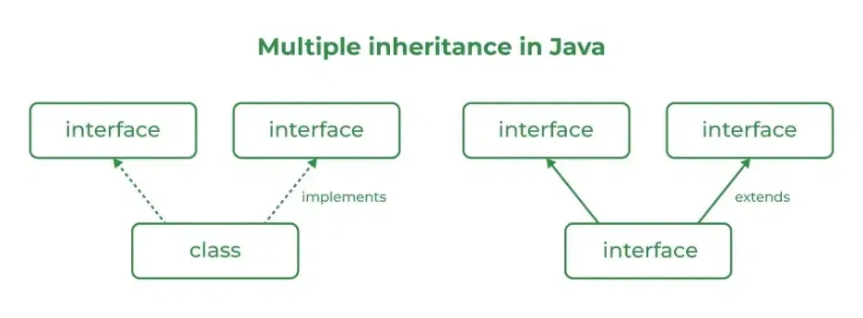

**Source Code**

import java.io.*;

  // Add interface

interface Add{

    int add(int a,int b);

}

// Sub interface

interface Sub{

   int sub(int a,int b);

}

// Calculator class implementing Add and Sub

class Cal implements Add , Sub

{

// Method to add two numbers

   public int add(int a,int b){

       return a+b;

    }

      // Method to sub two numbers

   public int sub(int a,int b){

     return a-b;

    }

}

class Example{

    // Main Method

    public static void main (String[] args){

       // instance of Cal class

       Cal x = new Cal();

       System.out.println("Addition : " + x.add(2,1));

       System.out.println("Substraction : " + x.sub(2,1));

    }

}

**Outputs**

Addition : 3   
Subtraction : 1

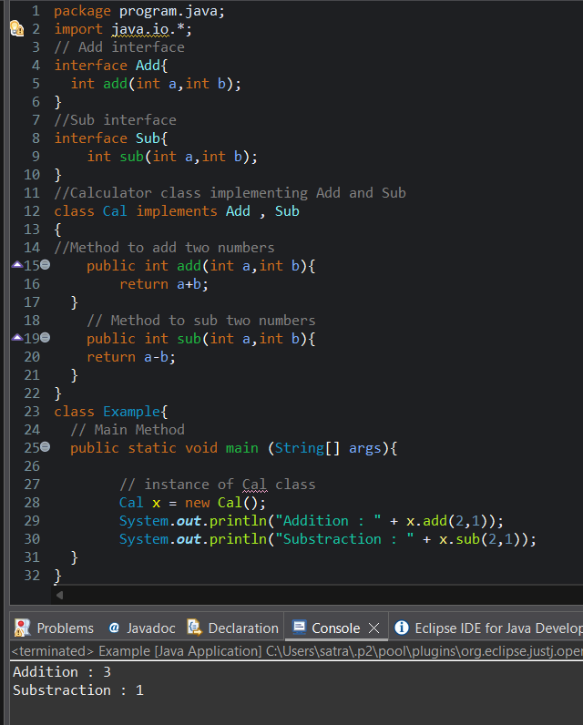

**POST LAB EXERCISE**

* 1. Can a functional interface extend another interface?

Yes, a functional interface can extend another interface in Java.  
However, after extending, it must still contain **only one abstract method** in total.  
If extending another interface adds more abstract methods, then it will no longer be considered a functional interface.

* 1. Which feature was introduced in interfaces starting from Java 8?

1. Constructors
2. Private methods
3. Default and static methods
4. Final classes

**Correct Answer:**  
**C. Default and static methods**

From Java 8, interfaces can contain **default and static methods**, which allow method implementations inside interfaces

**ASSESSMENT**

|  |  |  |
| --- | --- | --- |
| **Description** | **Max Marks** | **Marks Awarded** |
| Pre Lab Exercise | **5** |  |
| In Lab Exercise | **10** |  |
| Post Lab Exercise | **5** |  |
| Viva | **10** |  |
| **Total** | **30** |  |
| **Faculty Signature** | |  |

**Experiment Number : 12 Date:**

**Implementation of exception handling in Java**

**Aim:**

**Write a java program to implement exception handling.**

**PRE LAB EXERCISE**

**QUESTIONS**

1. What is exception handling in Java?

Exception handling in Java is a mechanism to handle **runtime errors** so that the normal flow of the program is maintained. It prevents program termination by handling exceptions using try, catch, finally, throw, and throws.

1. What is the purpose of using try-catch blocks in exception handling?

The purpose of using try-catch blocks is to **detect and handle exceptions** that may occur during program execution. The try block contains code that may cause an exception, and the catch block handles the exception to prevent abnormal termination of the program.

**IN LAB EXERCISE**

**Objective**

To understand and implement exception handling through try-catch and finally blocks.

**Source Code**

import java.util.InputMismatchException;

import java.util.Scanner;

public class ExceptionHandlingExample {

public static void main(String[] args) {

Scanner scanner = new Scanner(System.in);

try {

System.out.print("Enter an integer: ");

int num = scanner.nextInt();

int result = 10 / num;

System.out.println("Result: " + result);

} catch (InputMismatchException e) {

System.out.println("Invalid input! Please enter an integer.");

} catch (ArithmeticException e) {

System.out.println("Cannot divide by zero!");

} finally {

scanner.close();

System.out.println("Program execution completed.");

} }

}

**Outputs**

**Output 1 (Valid Input - Non-zero Integer):**

Enter an integer: 5

Result: 2

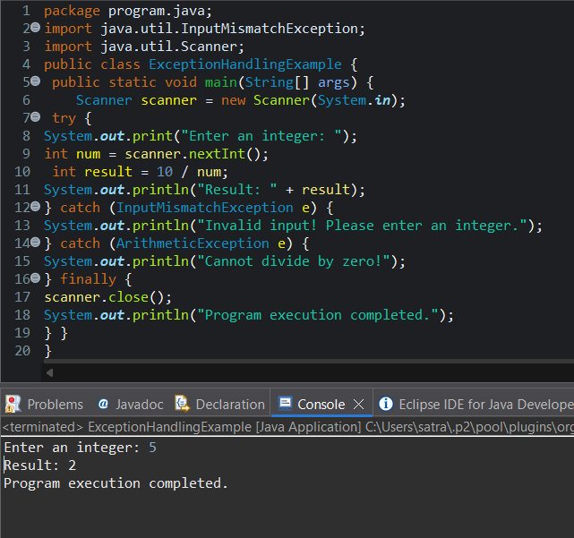

Program execution completed.

**Output 2 (Valid Input - Zero):**

Enter an integer: 0

Cannot divide by zero!

Program execution completed.

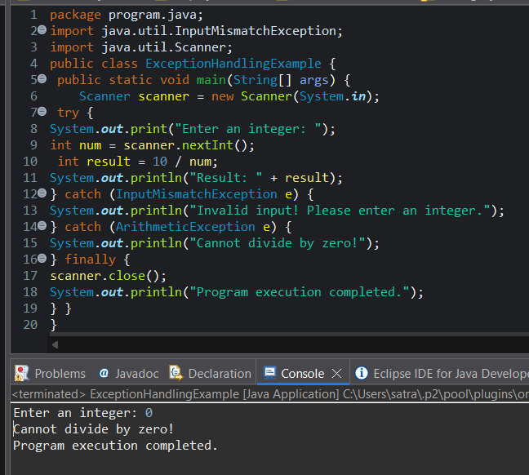

**Output 3 (Invalid Input - Non-integer):**

Enter an integer: abc

Invalid input! Please enter an integer.

Program execution completed.

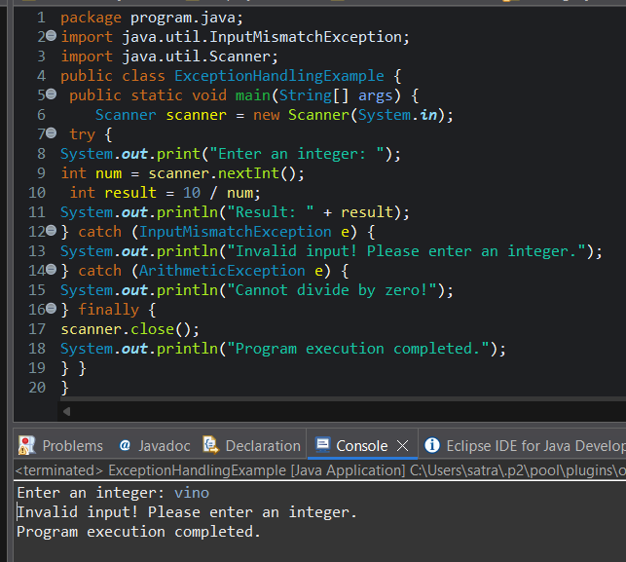

**POST LAB EXERCISE**

1. What is the purpose of the Scanner object in the Java program?

The Scanner object is used to **read input from the user** (such as integers, strings, etc.) from standard input (System.in) during program execution.

1. What exceptions are expected to be thrown in the code within the try block? Why?

Common exceptions expected inside a try block when using Scanner are **InputMismatchException** and **NoSuchElementException**.  
These occur when the user enters an input of the **wrong data type** or when **no input is available**, respectively.

**ASSESSMENT**

|  |  |  |
| --- | --- | --- |
| **Description** | **Max Marks** | **Marks Awarded** |
| Pre Lab Exercise | **5** |  |
| In Lab Exercise | **10** |  |
| Post Lab Exercise | **5** |  |
| Viva | **10** |  |
| **Total** | **30** |  |
| **Faculty Signature** | |  |

**Experiment Number : 13 Date:**

**Implementation of User-defined Exception in Java**

**Aim:**

**Write a java program to implement User-defined Exception.**

**PRE LAB EXERCISE**

**QUESTIONS**

1. What is Java custom exception?

A Java custom exception is a user-defined exception created by extending either the Exception class or the RuntimeException class to handle specific error conditions in a program.

1. What are the two types of custom exceptions in Java?

**2. Two Types of Custom Exceptions in Java**

Custom exceptions in Java can be classified into **two types**:

* **Checked Custom Exception**
  + Extends the Exception class.
  + Must be **declared in the method signature** using throws or **handled using try-catch**.
  + Example: class MyCheckedException extends Exception { ... }
* **Unchecked Custom Exception**
  + Extends the RuntimeException class.
  + **No need to declare or handle** explicitly. It can propagate at runtime.
  + Example: class MyUncheckedException extends RuntimeException { ... }

**IN LAB EXERCISE**

**Objective**

To understand and implement Checked and Unchecked custom exceptions.

**Source Code**

Ex 1: // Custom Checked Exception

class InvalidAgeException extends Exception {

public InvalidAgeException(String m) {

super(m);

}

}

// Using the Custom Exception

public class AgeCheck{

public static void validate(int age)

throws InvalidAgeException {

if (age < 18) {

throw new InvalidAgeException("Age must be 18 or above.");

}

System.out.println("Valid age: " + age);

}

public static void main(String[] args) {

try {

validate(12);

} catch (InvalidAgeException e) {

System.out.println("Caught Exception: " + e.getMessage());

}

}

}

**Output 1**

Caught Exception: Age must be 18 or above.

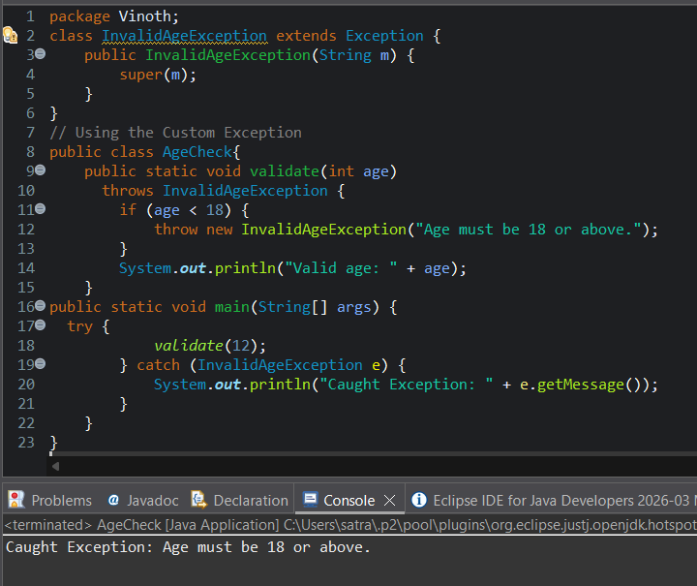

Ex 2: // Custom Unchecked Exception

class DivideByZeroException extends RuntimeException {

public DivideByZeroException(String m) {

super(m);

}

}

// Using the Custom Exception

public class TestSample {

public static void divide(int a, int b) {

if (b == 0) {

throw new DivideByZeroException("Division by zero is not allowed.");

}

System.out.println("Result: " + (a / b));

}

public static void main(String[] args) {

try {

divide(10, 0);

} catch (DivideByZeroException e) {

System.out.println("Caught Exception: " + e.getMessage());

}

}

}

**Output 2**

Caught Exception: Division by zero is not allowed.

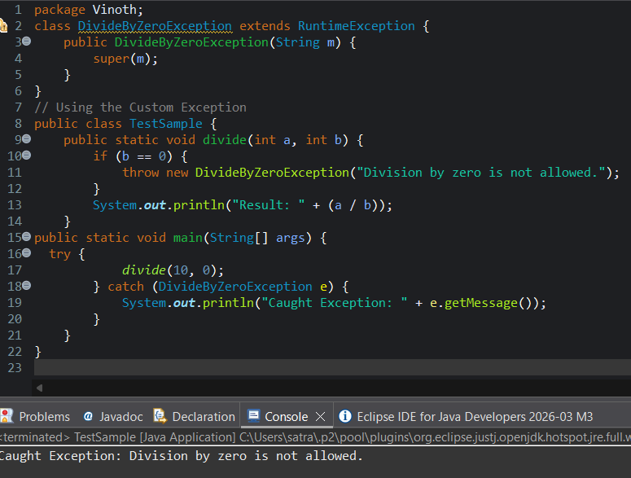

**POST LAB EXERCISE**

1. What is required to create a custom exception in Java?
2. Extend the Object class
3. Extend the Throwable class
4. Extend Exception or RuntimeException
5. Implement the Serializable interface

**Answer:**  
**C. Extend Exception or RuntimeException** ✅

* To create a custom exception, you extend either Exception (for checked exceptions) or RuntimeException (for unchecked exceptions).

1. List some use cases for the checked and unchecked exceptions.

**Use Cases for Checked and Unchecked Exceptions**

| **Type** | **Typical Use Cases** |
| --- | --- |
| **Checked Exception** | - File handling (FileNotFoundException) - Database operations (SQLException) - Invalid input that the caller can recover from |
| **Unchecked Exception** | - Programming errors like NullPointerException - Arithmetic errors like divide by zero - Invalid method calls or illegal arguments |

**ASSESSMENT**

|  |  |  |
| --- | --- | --- |
| **Description** | **Max Marks** | **Marks Awarded** |
| Pre Lab Exercise | **5** |  |
| In Lab Exercise | **10** |  |
| Post Lab Exercise | **5** |  |
| Viva | **10** |  |
| **Total** | **30** |  |
| **Faculty Signature** | |  |